**Get Help:** 24/7 Trafficking Hotline

1-888-3737-888

Confidential help and information

**Images and Headlines:**

1. #1
   1. **Headline-** 27 MILLION SLAVES TODAY
   2. **Image-** MANNA Freedom Video
   3. **Byline:** More than 27 million people live in slavery today. That’s more than twice as many people taken from Africa during the 350 years of the Atlantic Slave trade…
   4. **Learn More>** What is Human Trafficking? (Template #2; 2nd level subpage)

Headline: 27 MILLION SLAVES TODAY

Image: 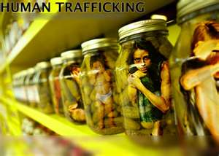

2. #2

1. **Headline-** SURVIVOR STORIES & VIDEOS
2. **Image-** 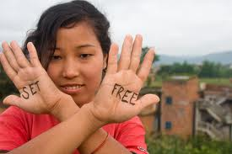
3. **Byline-** Hello, my name is Theresa. I am a survivor of slavery in America. When I was 15 my parents moved to a new city in Michigan…
4. **Learn More>** Survivor Stories& videos (Template #3; 2nd level subpage)

**Headline #1-**Hello my name is Theresa. I am a survivor of slavery in America.

**Image #1-**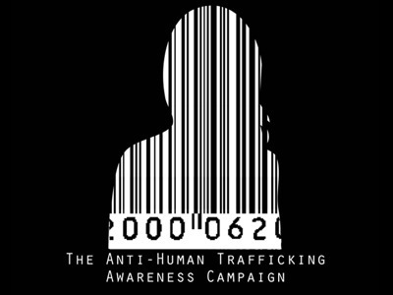

**Headline #2-**16 year old Shauna Newell’s story of being abducted, drugged and gang raped.

**Image #2-** thumbnail of video

**Headline #3-** I’m a victim, not a criminal

**Image #3-** thumbnail of video

**Headline #4-** Danielle

**Image #4-** thumbnail of video

Page two Survivor Stories and Videos

**Headline #1-** A Beautiful Slave

**Image #1-** thumbnail of video

**Headline #2-** Sex Trafficking PSA

**Image #2-** thumbnail of video

**Headline #3-** Little Child

**Image #3-** thumbnail of video

**Headline #4-** My Dangerous Loverboy

**Image #4-** thumbnail

1. #3
   1. **Headline-** TEST YOUR KNOWLEDGE ABOUT HUMAN TRAFFICKING



* 1. **Image**
  2. **Byline-** What is human trafficking? How many American children are affected by sex trafficking? What is a “john school”….
  3. **Learn More>**Get Informed>FAQ (Template #2; 2nd level subpage)

**Headline-** MOST OF US WOULD NEVER GUESS

**Image-**

1. #4
   1. **Headline-** FREE RESOURCE CENTER
   2. **Image-** 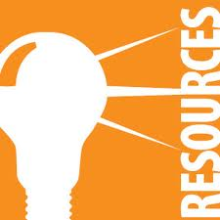
   3. **Byline-** Valuable information at your fingertips. For educators, community leaders, law enforcement personnel, parents, healthcare professionals, religious leaders, ….
   4. **Learn More>**Get Informed>Resource Center (Template #2; 2nd level subpage)

**Headline-** Get equipped to share what you’ve learned with others.

**Image- **

**Downloadable PDFs**

10 Quick Facts About Child Sex Slavery

Signs of Sexual Exploitation

Internet Safety Tips

Top 10 Characteristics of a Child Predator

Dept of Health and Human Services pamphlet for Social Service providers

Dept of Health and Human Services pamphlet for law enforcement and healthcare providers

(Internal hyperlinks for: FAQ, Links to other organizations)